Nonparametric Tests App User Guide

Ivy(Ruxin) Tong

# Goal of the application

The app is designed for users to run Kruskal-Wallis (KW) rank sum test and Jonckheere-Terpstra (JT) test. Users can test if there are any statistically significant mean differences between multiple groups of the data and if there is an ascending order of the mean differences among the groups. It will produce the boxplot of your data, output the JT and KW test p value, and generate the JT star histogram.

# File Requirements

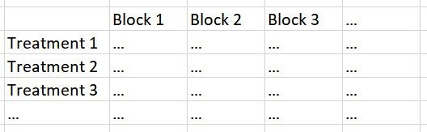It is required that file uploaded should be in the text format. Additionally, it should be formatted in such a way that groups should be in the rows and blocks should be in columns. Each group is required to have the same sample size.

# Contents of the application

* 1. ***Nonparametric Tests are used in the app***

The app runs two nonparametric tests:

Kruskal-Wallis rank sum test can be used to identify statistically significant mean differences between two or more groups of an independent variable.

Jonckheere-Terpstra test tests for the significant ordered differences in mean. The app is specifically designed to test the ascending order of mean differences.

# Backend Function

**KW Test:** The Kruskal-Wallis test determines whether two or more groups have significant difference in means.

H0: μ1 = μ2 = … = μn

HA: at least one of them is different from each other

The data should be formatted with each treatment separated by row. The test reads the data and determines the number of treatment groups. Then, it combines all the data into a single list, determines the total number of data points, and ranks the data. The expected mean rank and the average rank per group will be calculated.

The KW statistic is calculated by taking the difference of each treatments mean rank and the expected mean rank. The differences are then squared, multiplied by the number of data points in a treatment, and summed. This sum is scaled and produces the KW observed statistic.

In order to calculate the p-value for the data, you have to choose the number of permutation R. A sample is taken from the combined data. KW statistics are calculated and stored. The p-value is calculated by finding the number of those new KW statistics that are larger than KW observed and dividing that quantity by the permutation size R. The app then displays the p-value.

**JT Test**: The Jonckhere-Terpstra tests if there is an order to the mean results of different treatments or groups. The hypothesis for this test in this specific application is:

H0: τ1 = τ2 = … = τK HA: τ1 ≤ τ2 ≤ … ≤ τK

The data should be formatted with each treatment separated by row.

The app will produce a histogram of the null distribution and where the JTobs lies on that distribution. The p-value is calculated by dividing the number of JTstars that are greater than or equal to JTobs by the number of permutations. Then, p value will be generated.

# An applied example

File used: “hay.txt” 1: Upload the txt.file.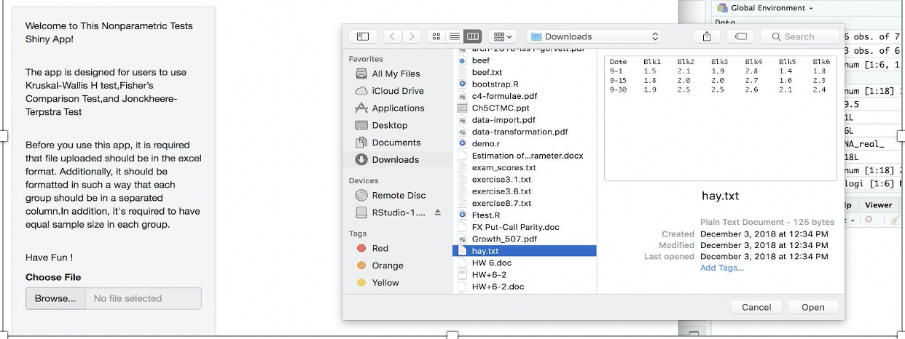

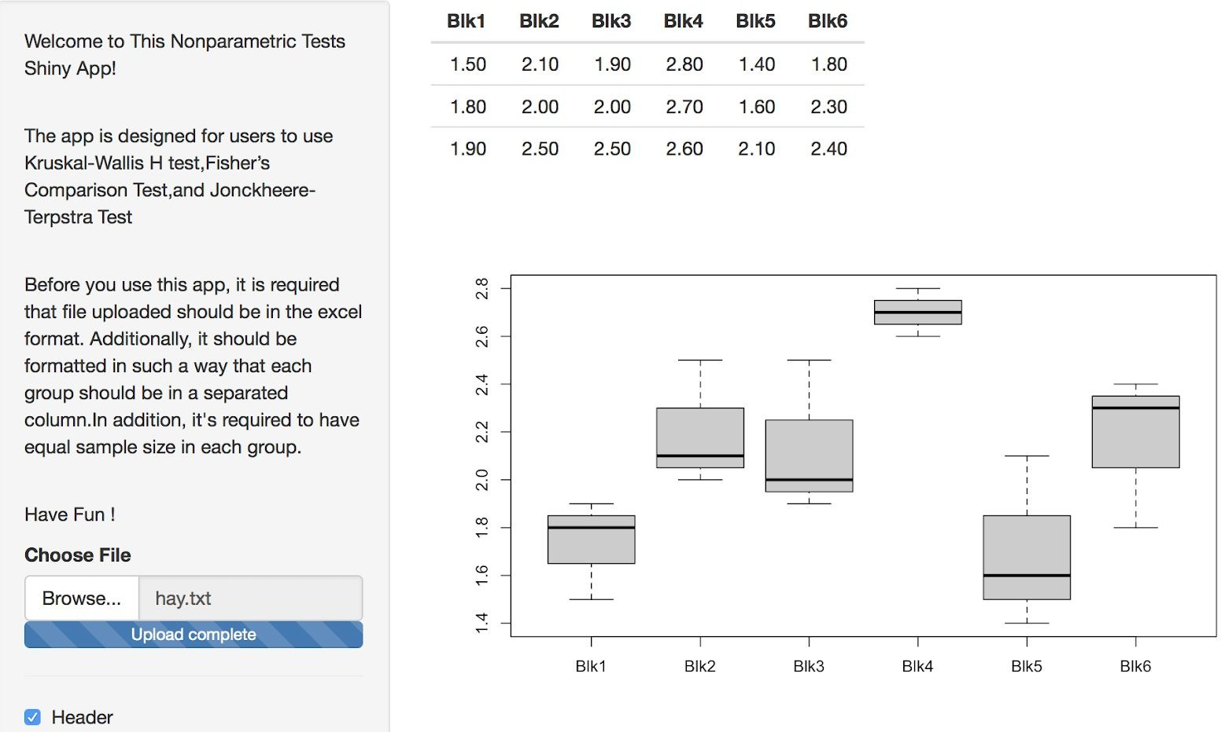2: Select Separator, Quote, Display based on the data structure. I selected separator to be “tab” And “ Double Quote”

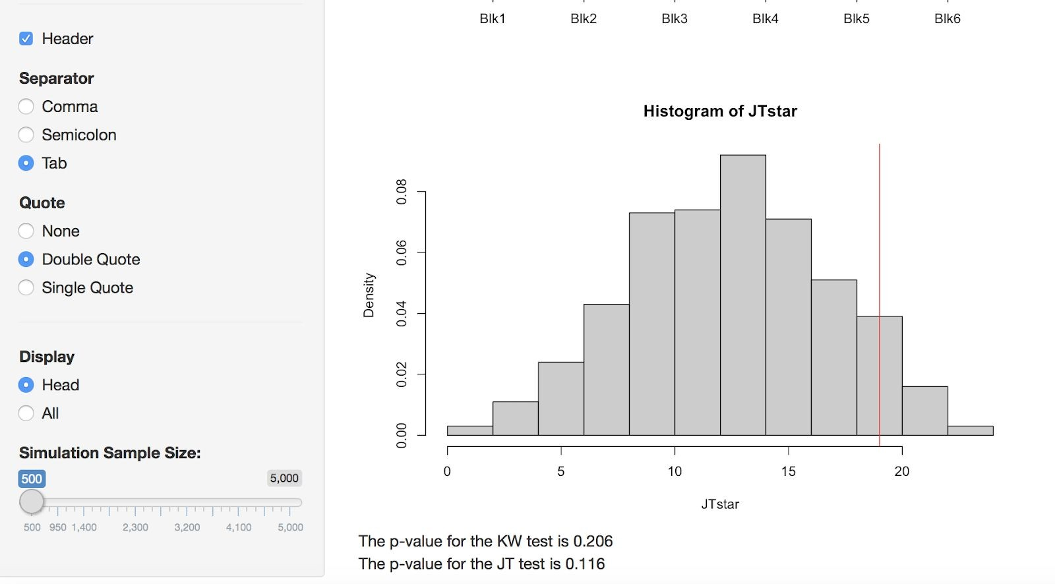

You will be able to see the data, the boxplot of the data, the histogram of the JT star, the p value of JT test, and the p value of the KW test. As can be seen from the P value output, both p values are greater than alpha level 0.05, thus null hypothesis cannot be rejected. There are no statistically significant mean differences, and there are no significant ascending mean differences.

3. You could use the sample size slider to choose permutations samples size. Graph and P value outputs will change based on simulation sample size.

